**SYSC 3303 Project**

**Team Number:** Group 1

**Lab Section:** 3

**Team Members:**

1. Ankur Mishra
2. Dhrubomoy Das Gupta
3. Vadim Yastrebov
4. Muhammad Zeeshan

Table of Contents

Breakdown of Responsibilities: 3

Diagrams: 4

UCM Diagrams: 4

UCM Diagram for RRQ: 4

UCM Diagram for WRQ: 5

Timing Diagrams: 5

Error 04 (Large Data packet) 5

Error 04 (Wrong Opcode) 6

Error 05 (Invalid TID) 6

UML Diagrams: 7

UML Class Diagram for Package **“packet”** 7

UML Diagram for package “**tftp**” 8

Setup Instruction: 9

Loading the project: 9

Running the program: 9

# Breakdown of Responsibilities:

**Ankur Mishra** : Design, Coding

**Dhrubomoy Das Gupta** : Design, Coding, README, Setup Instructions, UML Diagrams

**Vadim Yastrebov** : Design, Coding

**Muhammad Zeeshan** : Design, Coding, UCM diagram and Timing diagram

# Diagrams:

## UCM Diagrams:

### UCM Diagram for RRQ:

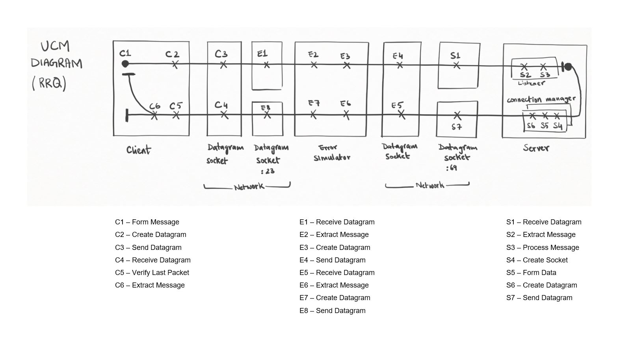

### UCM Diagram for WRQ:

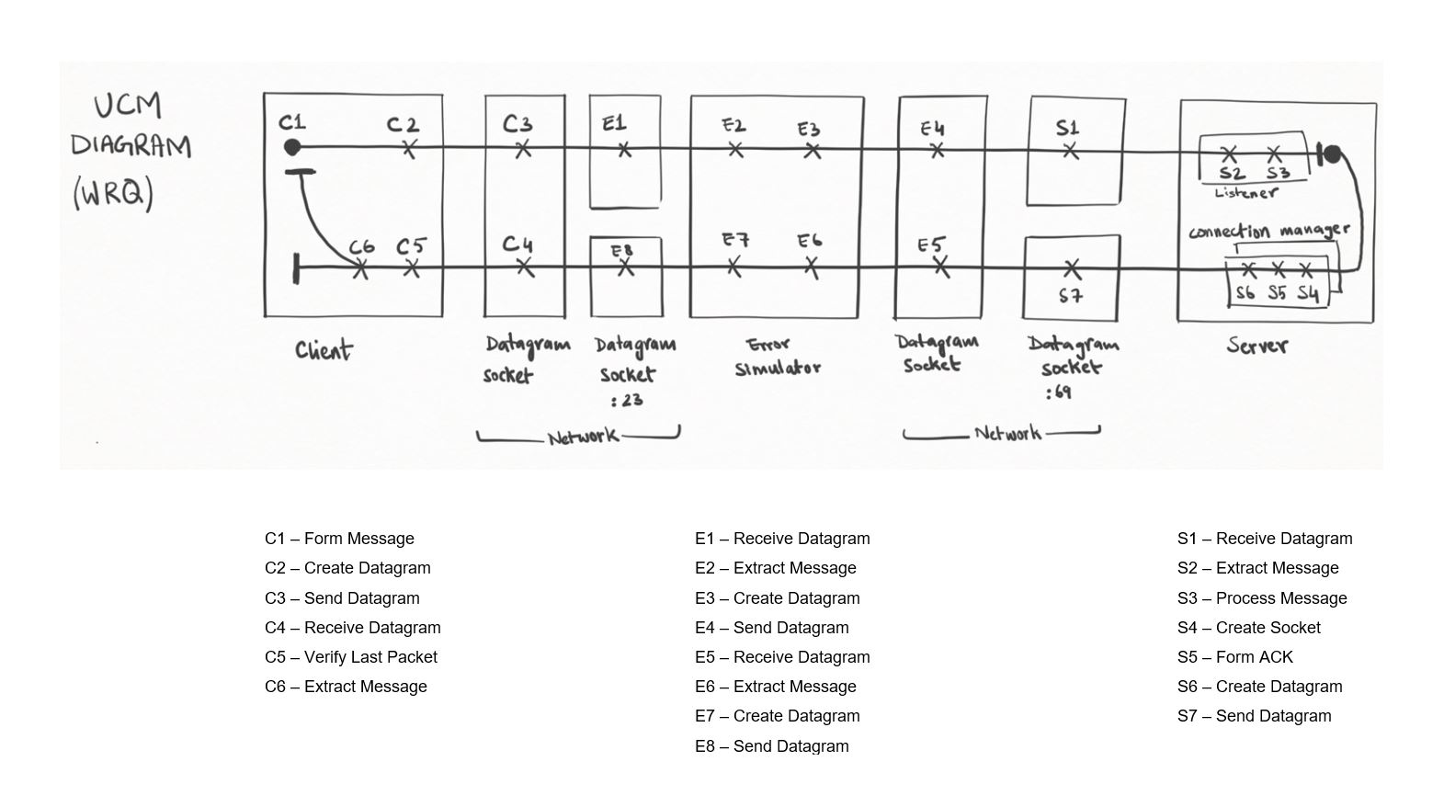

## Timing Diagrams:

### Error 04 (Large Data packet)

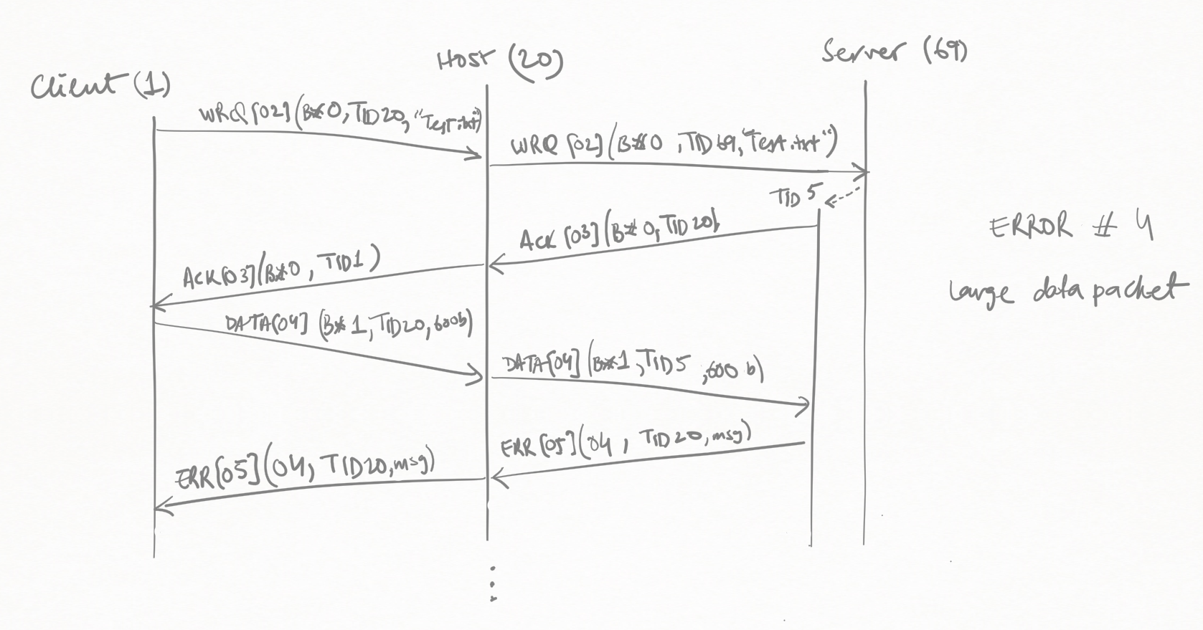

### Error 04 (Wrong Opcode)

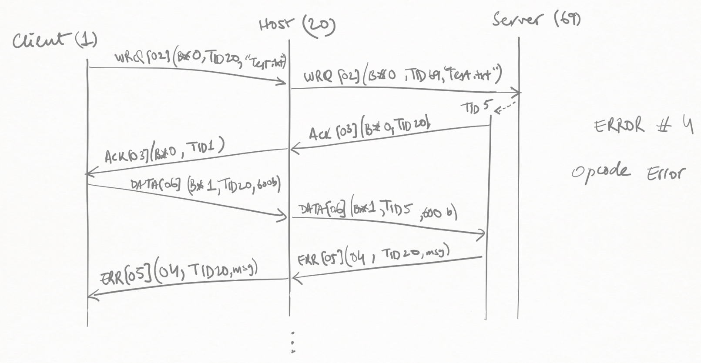

### Error 05 (Invalid TID)

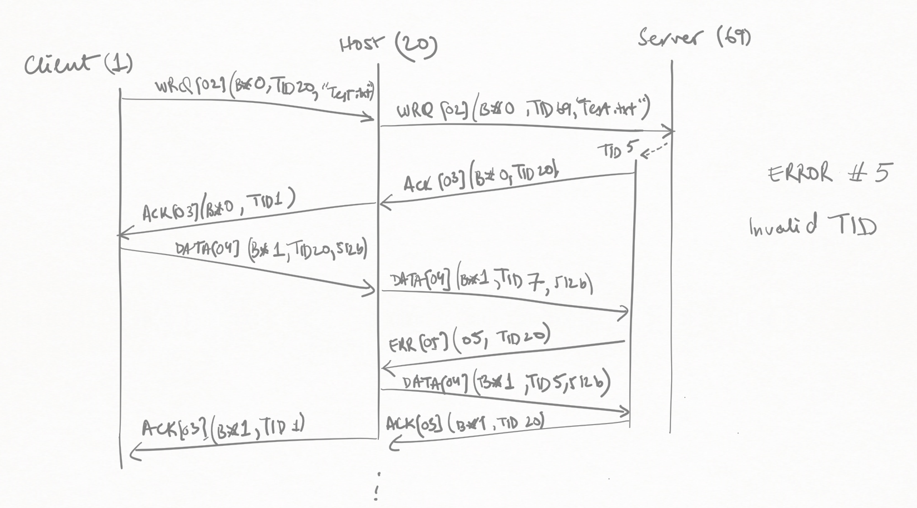

## UML Diagrams:

### UML Class Diagram for Package **“packet”**

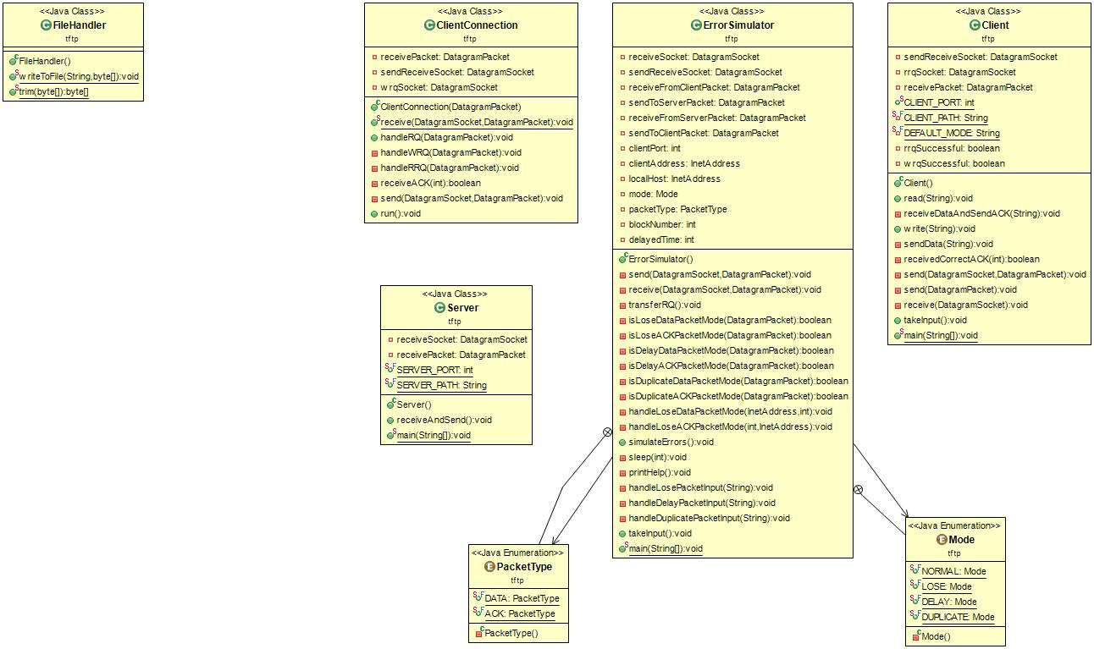

### UML Diagram for package “**tftp**”

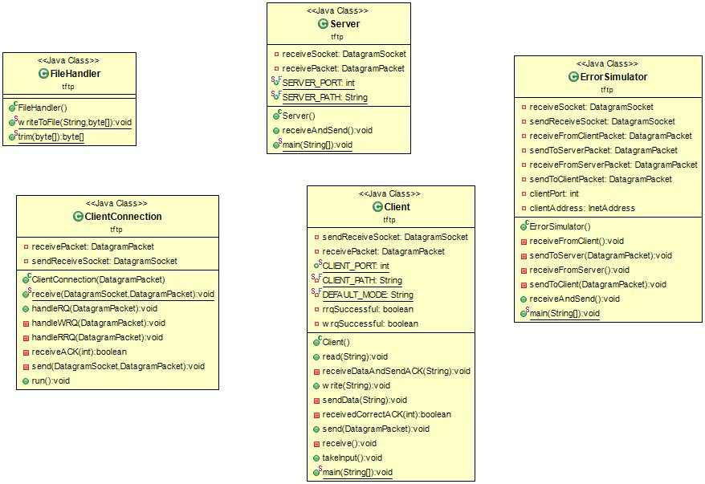

# Setup Instruction:

## Loading the project:

1. Open eclipse-java.
2. Select **File > Import**.
3. Select **General > Existing Projects into Workspace**, and click **next**.
4. Make sure that **Select Archive File** is checked and browse for ***L3G1_project_it2.zip***.
5. Click **Finish**.

## Running the program:

1. For running multiple programs simultaneously in Eclipse, right click on each source file (Client.java, Host.java and Server.java) and choose: "Run As >> Java Application". (Ensure that each program runs in a separate console window.)   
   See <https://stackoverflow.com/a/5453914>
2. **Run "Server.java"** (Under "tftp" package).
3. **Run "ErrorSimulator.java"** (Under "tftp" package).  
   **Note:** Error Simulator must be run where the **client** is running

* For normal operation enter ‘0’
* To lose a packet enter   
   **1 [Block #] [DATA or ACK]**   
   (e.g. '1 2 DATA', '1 3 ACK' etc.)
* To delay a packet enter  
   **2 [Block #] [DATA or ACK] [How much delay (in miliseconds)]**  
   (e.g. '2 2 DATA 3000', '2 3 ACK 2500' etc.)
* To duplicate a packet enter:  
   **3 [Block #] [DATA or ACK] [Space between duplicates ((in miliseconds))]**  
   e.g. '3 2 DATA 3000', '3 3 ACK 2500' etc.
* To simulate invalid TFTP opcode on RRQ or WRQ:  
   **4**
* Simulate invalid mode:  
   5
* Illegal TFTP operation:   
   **6 [Block #] [DATA or ACK]**  
   e.g. '6 2 DATA', '6 3 ACK' etc.

1. **Run "Client.java"** (Under "tftp" package)  
   Type and enter following:

* To read a file from server  
   **read [filename] [host address (optional)]  
   e.g. 'read server_big.txt 192.168.46.1'**
* To write a file to server  
   **write [filename] [host address (optional)]**  
   **e.g. 'write client_big.txt 192.168.46.1'**  
  *** **NOTE**:

For RRQ: the file must reside in "test_files/server" folder. (e.g 'server_big.txt')

For WRQ: the file must reside in "test_files/client" folder. (e.g 'client_big.txt')

1. For RRQ: The file now should be transferred to the 'test_files/client' folder from server.
2. For WRQ: The file should be transferred to the 'test_files/server' folder from client.
3. On the server console enter 'exit' to shut down server OR enter 'c' to continue.  
   Note: Must enter 'c' to continue transferring file.
4. On the client console either enter 'exit' to shut down client.